**《Fundamentals of Electric Circuits》homework 2**

3.8 Using nodal analysis, find vo in the circuit of Fig. 3.57. (10’)

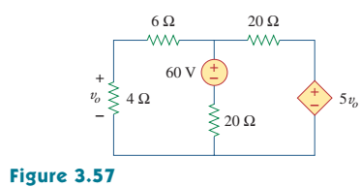

3.16 Determine voltages v1 through v3 in the circuit of Fig. 3.65 using nodal analysis . (10’)

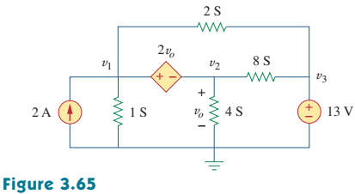

3.18 Determine the node voltages in the circuit in Fig. 3.67 using nodal analysis . (10’)

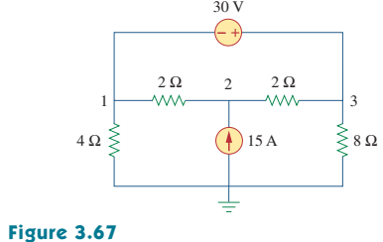

3.23 Use nodal analysis to find vo in the circuit of Fig. 3.72 . (10’)

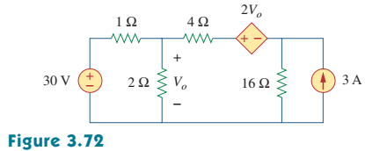

3.40 For the bridge network in Fig. 3.86, find i0 using mesh analysis . (10’)

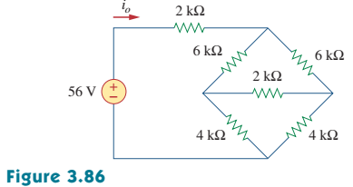

3.45 Find current i in the circuit of Fig. 3.91 . (10’)

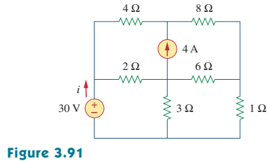

3.50 Use mesh analysis to find the current i0 in the circuit of Fig. 3.95 . (10’)

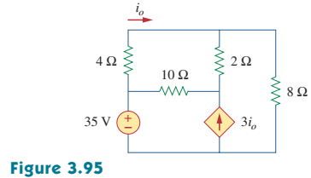

3.52 Use mesh analysis to find i1, i2 and i3 in the circuit of Fig. 3.97 . (10’)

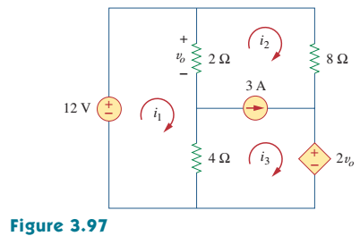

3.73 Write the mesh-current equations for the circuit in Fig. 3.117 . (10’)

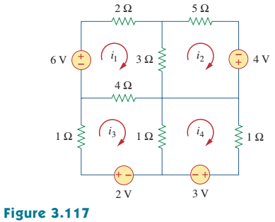

3.89 For the transistor circuit shown in Fig. 3.125, find IB and VCE .Let β= 100 and VBE=0.7V . (10’)

